MINIOR PROJECT ON

Submitted
In the partial fulfilment of the requirements for
The award of the degree of
BACHELOR OF TECHNOLOGY
In
COMPUTER SCIENCE & ENGINEERING
By

KRISH SINGH.T - 20U51A0588
DATTA SAI.V - 20U51A0592
SAI KIRAN.S - 21U55A0518
MURALI.K - 21U55A0511
RAVI TEJA.N - 21U55A0516

Under the Guidance of
Mrs.B Uma Devi

DEPARTMENT OF COMPUTER SCIENCE & ENGINEERING
DRK COLLEGE OF ENGINEERING AND TECHNOLOGY
Affiliated to JNTU HYDERABAD
Bowrampet, HYDERABAD-500043.

DEPARTMENT OF COMPUTER SCIENCE & ENGINEERING
DRK COLLEGE OF ENGINEERING AND TECHNOLOGY
Affiliated to JNTUH HYDERABAD,
Bowrampet, HYDERABAD-500043.

CERTIFICATE
This is to certify that the Project Report entitled “MRI Vision: Enhancing Brain Tumor Classification with VGG16 and Transfer Learning” that is being submitted by T.KRISH SINGH(20U51A0588), V.DATTA SAI (20U51A0592), S.SAI KIRAN (21U55A0518), K.MURLI (21U55A0511), N.RAVI TEJA (21U55A0516) in partial fulfillment for the award of B. Tech degree in Computer Science and Engineering to the DRK COLLEGE OF ENGINEERING AND TECHNOLOGY affiliated to JNTU HYDERABAD, is a record of bonafide work carried out by them under the supervision of faculty member of CSE Department.

Guide External Examiner HOD, CSE Principal

DEPARTMENT OF COMPUTER SCIENCE & ENGINEERING
DRK COLLEGE OF ENGINEERING AND TECHNOLOGY
Affiliated to JNTUH HYDERABAD,
Bowrampet, HYDERABAD-500043.

DECLARATION

I hereby declare that the PROJECT “MRI Vision: Enhancing Brain Tumor Classification with VGG16 and Transfer Learning” submitted for the DEPARTMENT OF COMPUTER SCIENCE AND ENGINEERING. This dissertation is our original work and the PROJECT has not formed the basis for the award of any degree, associate-ship, and fellowship, or any other similar titles, and no part of it has been published or sent for publication at the time of submission.
BY
KRISH SINGH.T
DATTA SAI.V
SAI KIRAN.S
MURALI.K
RAVI TEJA.N
Date: 7/12/2023

ACKNOWLEDGEMENT

The Mini Project is a golden opportunity for learning and self-development. Consider myself very lucky and honored to have so many wonderful people lead me through in the completion of this Major Project.

I would like to articulate my deep gratitude to my guide Mrs. B.UMA DEVI for his/her continuous support throughout the project. We are thankful to our project coordinators Mr. J. Sunil Kumar , for their advice throughout project.

We take the privilege to thank DR.Kanaka Vardhini, HoD-CSE, for her assistance during the project. We also thank our vice-principal Prof. M.Srinivasa Rao, who has made the atmosphere so easy to work.

I gratefully express my sincere thanks to our beloved principal Prof. (Dr.)Gnaneswara Rao Nitta, for his continuous support and making it possible to complete the project in time.

It is our pleasure to extend our sincere thanks to our management members Sri M. Chandra Sekhara Rao Director, Sri D Sriram Treasurer, and Honourable Chairman Sri. D B Chandra Sekhar Rao.

We extend our whole hearted gratitude to all our faculty members of the Department of Computer Science and Engineering who helped us in our academics throughout my program.

Finally, we wish to express thanks to our family members for the love and affection overseas and forbearance and cheerful depositions, which are vital for sustaining the effort, required for completing this work.

KRISH SINGH.T - 20U51A0588
DATTA SAI.V - 20U51A0592
SAI KIRAN.S - 21U55A0518
MURALI.K - 21U55A0511
RAVI TEJA.N - 21U55A0516

Dedicated to my beloved

PARENTS

TABLE OF CONTENTS

TITLE | Page. no
List of figures
Abstract | 9
Chapter 1: INTRODUCTION | 10-14
1.1. Introduction | 10
1.2. Literature Survey | 11
1.3. Project Background | 12
1.4. Objectives | 13
1.5. Issues | 14
Chapter 2: SOFTWARE REQIUREMENT SPECIFICATION 14-23
2.1. Requirement Analysis | 14
2.2. Problem Statement | 15
2.3. Functional Requirements  2.4. Software Requirement Specification | 16  17
2.4.1. Purpose | 17
2.4.2. Scope | 18
2.4.3. Technologies Used | 18
2.4.4. Overview | 19
2.4.5. Product Perspective  2.5. Software Requirements | 19  19
2.6. Hardware Requirements | 20
2.7. Functional Requirements | 20
2.8. Non-Functional Requirements | 20
2.9. External Interface Requirements | 20
2.10. Modelling | 21-23
Chapter 3: PROPOSED METHODOLOGY 24-33
3.1. Addressing Issues |  | 26
3.2. Block Diagram |  | 27
3.3. Proposed Methodology |  | 27
3.3.1. Data Pre-processing |  | 27
3.3.2. Random Forest |  | 28
3.3.3. Decision Tree |  | 28
3.3.4. Logistic Regression  3.3.5. Gradient Boosting  3.3.6. K-Nearest Neighbours |  | 29  30  31-33
Chapter 4: RESULTS AND DISCUSSIONS | 33-38
4.1. Data Sets and their description  4.2. Tools and Languages | 33  34-35
4.3. Performance Metrics | 35-37
4.4. Results and its Discussions | 37-38
Chapter 5: CONCLUSIONS AND FUTURE SCOPE | 38-40
REFERENCES | 40-43

LIST OF FIGURES

Fig-no | List of figures | Page.no
2.10 | Modeling(design data flow diagram)
2.10-1 | Flowchart of brain tumour MRI classification.
2.10-2 | Class Diagram of brain tumour MRI classification.
2.10-3 | sequence diagram of brain tumour MRI classification.
3.2 | Block Diagram of Proposed methodology
4.4 | Results and its Discussions
4.4.1 | Classification model loss
4.4.2 | Classification model accuracy
4.4.3 | Accuracy per batch size
4.4.4 | Accuracy per Augmentation Setting
4.4.5 | Tumor Count Train Set
4.4.6 | Tumor Count Validation Set
4.4.7 | Tumor Count Test set

ABSTRACT

Brain tumors, ranging from benign to malignant, significantly impact global health, with statistics indicating a rising prevalence and mortality rate. The early and accurate classification of brain tumors through MRI scans is crucial for effective treatment and improved patient outcomes. The project addresses this critical need in the medical field. Motivated by the challenges of accurate tumor classification and the limitations of current diagnostic methods, this study aims to harness the power of advanced machine-learning techniques to improve brain tumor diagnostics.
The research employs the VGG16 architecture, a deep convolutional neural network, combined with transfer learning, to analyze the LGG Segmentation Brain MRI dataset. This methodology is selected for its proven effectiveness in image classification tasks and ability to adapt to medical imaging analysis. The primary objective is to develop a model that surpasses traditional classification methods in accuracy, speed, and reliability, providing a more nuanced understanding of MRI images.
The expected outcome is a significant enhancement in the classification of brain tumors, with the potential to provide rapid and precise diagnostic information. By leveraging the advanced capabilities of VGG16 and transfer learning, the study aims to offer a valuable tool for radiologists and oncologists, facilitating better-informed treatment decisions. This research not only contributes to medical imaging and oncology but also sets a precedent for applying deep learning in healthcare, potentially transforming diagnostic procedures and patient care in neurology.

CHAPTER 1
INTRODUCTION
  - Introduction

Brain tumours, which can be benign or malignant, are becoming more common and more deadly, which presents a serious threat to world health. Effective treatment and better patient outcomes depend critically on the early and precise classification of these tumours using MRI scans. Acknowledging this pressing need, our project aims to tackle the difficulties in accurately classifying tumours as well as the shortcomings of the medical field's existing diagnostic techniques.
Inspired by these difficulties, our research aims to transform brain tumour diagnosis by utilising cutting-edge machine-learning methods. We analyse the LGG Segmentation Brain MRI dataset using transfer learning combined with the VGG16 architecture, a deep convolutional neural network. This approach was selected due to its versatility and demonstrated effectiveness in image classification tasks.
Our main goal is to create a model that performs better than existing classification techniques, outperforming them in terms of accuracy, speed, and dependability and offering a more sophisticated interpretation of MRI images. We expect a significant improvement in brain tumour classification, and our work will provide accurate and timely diagnosis data. Through the utilisation of transfer learning and the advanced capabilities of VGG16, our goal is to provide radiologists and oncologists with a useful tool that will enable them to make more informed treatment decisions.
This project sets a groundbreaking precedent for the use of deep learning in healthcare in addition to making a substantial contribution to the fields of oncology and medical imaging. In the field of neurology, we hope that our research will revolutionise diagnostic practices and raise the bar for patient care.
1.2. Literature Survey
A literature survey , focusing on the detection of lower-grade glibloma brain tumors using CNNs in MRI scans, would involve an exploration of existing research, methodologies, and advancements in this specific domain. Here's an outline of what such a literature survey might cover are :
In 2023 the author Patel R. gave a better understanding on brain tumour classification .Author Patel R's research aimed to improve brain tumor classification using transfer learning, a technique that leverages pre-trained neural network models for new tasks. The study focused on applying transfer learning to medical imaging data, specifically MRI scans, for more accurate and efficient classification of brain tumors.
The research utilized a deep learning framework, possibly starting with a pre-trained model (like VGG16, ResNet, etc.) and fine-tuning it using a dataset of brain MRI scans. Transfer learning involves reusing the knowledge gained by the pre-trained model on a large dataset for the specific task of brain tumor classification.
In the year 2020 Author Zhang L.'s research aimed to explore the application of Convolutional Neural Networks (CNNs) for both segmentation and classification of brain tumors within MRI scans.The study likely involved two primary tasks: segmentation, which involves outlining and delineating the tumor region within MRI images, and classification, which involves categorizing the segmented regions into specific tumor types or classes.
Classification Phase: Once the tumor regions were segmented, the study might have used CNNs to classify these regions into different tumor types or classes based on characteristic features extracted by the network.
Zhang L.'s research have contributed insights into the capabilities of CNNs for precise tumor segmentation and classification in MRI scans, potentially providing advancements towards more accurate diagnostics and treatment planning.

1.3.Project Background
The project's inception stems from the realisation that brain tumors—which can range in type from benign to malignant—pose a serious threat to global health, as demonstrated by rising rates of both prevalence and mortality. Effective treatment and better patient outcomes depend critically on the urgent need for early and precise MRI scan classification of these tumours. To address these needs, our project is designed to address the difficulties in accurately classifying tumours as well as the shortcomings of current medical diagnostic techniques.
These difficulties are what drive our research, which aims to transform the field of brain tumour diagnosis by utilising cutting-edge machine-learning techniques. The strategy that was selected makes use of transfer learning in conjunction with the deep convolutional neural network architecture known as VGG16. This combination is chosen because it has a track record of success in image classification tasks and can be tailored to the nuances of medical imaging analysis.
Our main goal is to develop a model with superior accuracy, speed, and reliability compared to traditional classification techniques. This effort aims to provide a more sophisticated interpretation of MRI pictures and is projected to significantly improve the classification of brain tumours. With the help of our research, radiologists and oncologists will be able to make more informed treatment decisions by receiving fast and accurate diagnostic information.
This project sets a groundbreaking precedent for the use of deep learning in healthcare, even beyond its immediate effects on oncology and medical imaging. Our research has the potential to significantly change diagnostic processes, we believe.setting new standards in patient care within the field of neurology.
1.4. Issues
• Data Quality and Quantity: MRI datasets might be limited in size or quality, potentially leading to issues like class imbalance, noisy images, or insufficient representation of certain types of gliomas.
• Preprocessing Challenges: MRI images often require preprocessing steps like normalization, resizing, denoising, and alignment. Inaccurate or incomplete preprocessing can affect the model's ability to extract relevant features.
• Complexity of Glioma Types: Gliomas come in various types and grades, each with its own characteristics. Building a model that can accurately differentiate between different types and grades of gliomas is challenging.
• Interpretability: Deep learning models, especially convolutional neural networks (CNNs), might lack interpretability, making it hard to explain how the model arrives at its decisions. In medical scenarios, interpretability is crucial for trust and validation.
• Model Performance and Generalization: Ensuring that the model performs well not only on the data it was trained on but also on new, unseen data is crucial. Overfitting or underfitting can hinder the model's ability to generalize.
• Ethical Considerations: Any medical AI application needs to consider ethical implications, especially related to patient data privacy, biases in the dataset, and potential consequences of false positives or false negatives.
• Computational Resources: Training deep learning models on MRI datasets can be computationally intensive, requiring powerful hardware or specialized resources.
Addressing these issues involves a combination of data curation, preprocessing, feature extraction, model selection, validation techniques, and interpretability methods to ensure the model's accuracy, generalization, and ethical usage in glioma detection.
1.5. Objectives
- Detection of Tumors: Train a CNN for classification to identify the presence or absence of lower-grade glioma brain tumors from MRI images.
- Data Visualization: Explore the dataset, visualize the distribution of tumors among different age groups, and present images with their corresponding tumor masks for analysis and understanding.
- Data Splitting: Divide the dataset into training, validation, and test sets to train the models and evaluate their performance.
- Classification Model: Implement a CNN-based classification model (using a pre-trained VGG-16 as a base) to distinguish between tumor and non-tumor images. Experiment with data augmentation techniques (affine and elastic transforms) to enhance model performance.
- Evaluation: Evaluate model performance using accuracy metrics and assess the impact of different data augmentation strategies on classification accuracy and loss.
- Improving Brain Tumor Classification: Using VGG16 and transfer learning to enhance the accuracy, speed, and reliability of brain tumor classification in MRI images.
- Developing a Superior Diagnostic Tool: Creating a model surpassing traditional methods, aiding radiologists and oncologists in making better-informed treatment decisions.
- Advancing Medical Imaging and Oncology: Contributing to the fields of medical imaging and oncology by employing deep learning, potentially transforming diagnostic procedures and patient care in neurology.
- Identifying Future Research and Application Areas: Suggesting avenues for further research, such as optimizing the model's training, experimenting with different architectures, exploring multi-class classification, and integrating the technology into clinical settings and telemedicine platforms for wider accessibility.
The overarching goal is to create an accurate and robust system capable of identifying lower-grade glioma brain tumors in MRI scans, aiding in early detection and potentially assisting medical professionals in diagnosis and treatment planning.
CHAPTER 2
SOFTWARE REQUIREMENTS SPECIFICATION
2.1 Requirement Analysis
The requirements analysis involves determining and specifying the various functional and non-functional requirements for the software or system. Here's a breakdown:
- Functional Requirements:
Image Preprocessing: The system needs to preprocess MRI images to enhance features, remove noise, and standardize the input data for the detection algorithm.
Feature Extraction: Extracting relevant features from the MRI scans that are indicative of different types or grades of gliomas.
Classification: Implementing a classification algorithm (e.g., deep learning model) capable of accurately categorizing gliomas based on the extracted features.
Performance Evaluation: Incorporating metrics for evaluating the model's performance, such as accuracy, precision, recall, and F1-score.
Interface for Input/Output: Providing an interface to upload MRI scans, display the results, and offer options for further analysis or diagnosis.
- Non-functional Requirements:
Accuracy and Reliability: The system must achieve a high degree of accuracy and reliability in glioma detection across various types and grades.
Scalability: Ensuring that the system can handle an increasing number of MRI scans without a significant drop in performance.
Robustness: The model should perform consistently well across different MRI machines, imaging conditions, and patient demographics.
Interpretability: Providing explanations or visualizations of the model's decision-making process to aid clinicians in understanding the results.
Privacy and Security: Ensuring patient data privacy and compliance with medical data security standards like HIPAA.
Computational Efficiency: Optimizing the system to process MRI scans within a reasonable time frame to be practical for clinical use.
User Interface: Designing an intuitive and user-frienindly interface for healthcare professionals to interact with the system easily.
The requirements analysis aims to clearly outline what the system should do (functional requirements), how it should perform (non-functional requirements), and the ethical and regulatory considerations necessary for its deployment in the medical domain.

2.2 Problem Statement
The accurate identification and classification of brain tumors from MRI scans are crucial for timely diagnosis and treatment planning. However, manual analysis of these scans is time-consuming and prone to errors. The aim of this project is to develop a robust deep learning model that automates the classification of brain tumors from MRI images with high accuracy and reliability.
- Goals:
Accurate Classification: Create a model capable of accurately distinguishing between tumor and non-tumor regions in brain MRI scans, achieving high precision and recall.
Model Robustness: Develop a model that generalizes well to diverse MRI scans, handling variations in quality, imaging techniques, and tumor characteristics.
Feature Extraction and Representation: Extract and utilize relevant features from MRI images to represent tumor characteristics effectively.
Handling Class Imbalance: Address the challenge of class imbalance in the dataset, ensuring the model doesn't become biased toward the majority class while accurately identifying tumors.
Interpretability: Aim for a model that provides insights into the decision-making process, allowing medical professionals to understand and trust its classifications.
Ethical Compliance: Ensure adherence to ethical standards and regulations governing the use of sensitive medical data throughout the project.
Validation and Clinical Applicability: Conduct thorough validation procedures and aim for a model that can be practically used in clinical settings to assist medical professionals in diagnosing brain tumors effectively.
Scope: The project will involve data preprocessing, deep learning model development, rigorous evaluation, and validation to create a reliable and applicable solution for automated brain tumor classification from MRI scans.

A problem statement provides a clear overview of the challenges, objectives, and scope of the project, setting the direction for the development of the solution.
2.3 Functional Requirements
To accurately and early identify brain tumours in MRI scans, the project's functional requirements call for the creation of a complex model using cutting-edge machine learning techniques, most notably the VGG16 architecture with transfer learning. To address the existing limitations of brain tumour diagnostics, the model must prioritise improving upon conventional classification techniques, demonstrating superior accuracy, speed, and reliability. Furthermore, the model must be able to interpret MRI images with subtlety, detecting minute details that are necessary for a thorough examination of the features of brain tumours. This will enable a more accurate and sophisticated diagnosis than can be achieved with current techniques.
Moreover, the developed model should be able to provide accurate and timely diagnostic information, enabling medical professionals—especially radiologists and oncologists—to make more informed treatment decisions. Transfer learning and the advanced capabilities of VGG16 must be combined to produce a useful diagnostic tool that greatly improves patient outcomes by enabling more intelligent and effective treatment plans.
By demonstrating the revolutionary potential of machine-learning techniques in transforming brain tumour diagnostic procedures, the project aims to lead the way in implementing deep learning in healthcare, particularly in neurology. By offering a unique and cutting-edge approach to brain tumour diagnostics, it seeks to significantly advance the fields of medical imaging and oncology, possibly raising standards and influencing future techniques.The ultimate goal of the research is to set new benchmarks for patient care by serving as a catalyst for a fundamental transformation of neurology diagnostic processes.
2.4 Software Requirements Specification
The Software Requirements Specification (SRS) document is intended to provide the requirements of the MRI tumor classification in real time project. The document includes the project perspective, data model, and data related to overall patients.
2.4.1 Purpose
the context of Software Requirements Specifications (SRS) for a tumor segmentation code using CNN, the purpose entails defining and documenting the primary objectives and intentions of the software. It serves as a foundational element to guide the development and validation of the software.

- Specifically:
Defining Goals: It outlines the overarching goal of the software, such as accurately segmenting tumors in medical images using convolutional neural networks (CNNs).
Clarifying Objectives: It specifies the specific objectives the software aims to achieve, like achieving a certain level of accuracy or compatibility with various image modalities.
Setting Direction: The purpose section provides a clear direction for stakeholders, developers, and testers, ensuring everyone involved understands the fundamental intention behind the software.
Aligning Expectations: It helps align the expectations of stakeholders by clearly stating what the software intends to deliver in terms of functionality, performance, and quality.
Guiding Development: This section serves as a guide for the subsequent stages of software development, ensuring that the implemented features and functionalities align with the overall purpose and goals.
Ultimately, the purpose section within the SRS provides a concise and clear statement regarding the core reason and objectives for developing the tumor segmentation software using CNN.
2.4.2 Scope
The scope of the software requirements specification (SRS) for a tumor segmentation code using CNN refers to the boundaries and extent of what the software intends to accomplish. It defines the features, functionalities, constraints, and limitations of the software system. In this context:
Functional Scope: Describes the specific functionalities the software will perform, such as image preprocessing, CNN model architecture, tumor segmentation, and result visualization.
Non-Functional Scope: Covers aspects beyond direct functionalities, like performance requirements (such as processing time), usability, scalability, and maintainability.
Inclusions: Clearly identifies what the software will include, like support for various image modalities (MRI, CT scans), specific CNN architectures (e.g., U-Net, ResNet), and possibly integration with other medical imaging software or databases.
Exclusions: Explicitly states what the software will not address or provide. For instance, it might exclude certain types of tumors, other image processing tasks unrelated to segmentation, or compatibility with outdated hardware or software.
Constraints: Outlines any limitations or restrictions, such as budget constraints, hardware limitations, compatibility requirements with specific operating systems, or regulatory compliance.
Assumptions: Includes any underlying assumptions made during the software development process, such as the availability of labeled data for training the CNN or the reliability of the input images.
In summary, the scope section of the SRS sets the boundaries of the software's functionality, features, and constraints, ensuring a clear understanding of what the software will and will not encompass.
2.4.3 Technologies Used
Python
Python is an interpreter, high-level, general-purpose programming language. Created by Guido van Possum and first released in 1991, Python design philosophy emphasizes code reliability with its notable use of significant 15 whitespace. Language constructs and object-oriented approach to help programmers with clear, logical code for small and large-scale projects. Python is dynamically typed and garbage collected. It supports multiple Programming Paradigms, including procedural, Object oriented, and functional programming. Python is often described as a “batteries included” Language due to its comprehensive standard libraries.
Google Colaboratory
Colaboratory is a free Jupiter notebook environment that requires no setup and runs entirely in the cloud. With Colaboratory you can write and execute code, save and share your analyses, and access powerful computing resources, all for free from your browser. As the name suggests, Google Colab comes with collaboration backed in the product. It is a Jupiter notebook that leverages Google Docs collaboration features. It also runs on Google servers and you don’t need to install anything. Moreover, the notebooks are saved to your Google Drive account.
2.4.4 Overview
The project involves tumour classification using a Convolutional Neural Network (CNN) for medical image analysis. Here's an overview:
Objective: The main goal is to develop a CNN-based model that can accurately segment tumors from medical images like MRI or CT scans.
Approach: The code likely involves several steps:
Data Preprocessing: Preparing the medical images, which may involve resizing, normalization, or other preprocessing steps.
CNN Model Development: Creating or implementing a CNN architecture suitable for image segmentation. Architectures like U-Net are common for this task due to their effectiveness in medical image analysis.
Training: Using labeled data to train the CNN to recognize and segment tumors.
Validation: Assessing the trained model's performance using validation data to ensure it generalizes well to unseen examples.
Inference: Applying the trained model to new, unseen images to segment tumors.
Input: Medical images of patients (MRI, CT scans) containing tumor regions that need to be segmented.
Output: Segmented images or masks highlighting the tumor regions.
Key Components: It likely involves Python code using libraries like TensorFlow, PyTorch, or Keras for building and training the CNN. Additionally, it might include image processing libraries like OpenCV for preprocessing.
Significance: Medical image segmentation is crucial for diagnosis, treatment planning, and monitoring of diseases. Automating this process using deep learning techniques can assist medical professionals by providing accurate and efficient tools for analysis.
Remember, without seeing the actual code, this overview is based on common practices in tumor segmentation using CNNs for medical image analysis.
2.4.5 Product perspective
The product perspective of the code involves viewing it as part of a larger system or product geared towards medical image analysis. Here are some aspects to consider:
Integration within a Medical System: The code likely serves as a module within a broader medical imaging system. This system may involve modules for data storage, retrieval, visualization, and analysis of medical images.
Interoperability: It might need to integrate with existing hospital or clinic systems, ensuring compatibility with various image formats (DICOM, PNG, etc.) and providing an output format that seamlessly integrates with other tools or databases.
Scalability: Considering the potential increase in data volume, the system should be scalable to handle larger datasets efficiently. The model training and inference components should be optimized for performance.
Maintenance and Upgrades: Regular maintenance, updates, and improvements to the segmentation model are crucial. This includes monitoring the model's performance, retraining with new data, and upgrading the system to incorporate the latest advancements in the field.
User Interface (UI) and User Experience (UX): Depending on the context, there might be a need for a user-friendly interface for medical professionals to interact with the system, visualize the segmented images, and possibly make manual corrections if necessary.
Regulatory Compliance: Medical software needs to adhere to various regulations and standards to ensure patient data security, ethical use of AI in healthcare, and compliance with medical device regulations (if applicable).
Documentation and Support: Comprehensive documentation, user manuals, and support for users to understand, troubleshoot, and effectively use the system.
Ethical Considerations: Ensuring the system complies with ethical guidelines regarding patient data privacy, informed consent, and responsible use of AI in medical decision-making.
These perspectives help in understanding how the code fits into a larger context, emphasizing not just the technical aspects but also the practical implications and requirements of deploying such a system in a medical environment.
2.5. Software Requirements
The software requirements will consist of the essential components required for project development. The developer who works on the product will get all the answers which are required for the project development. The software requirements help predict the project cost and helpful in gathering all the tools for project development
The software requirements for this project are as follows:
- Operating System : Windows 10
- Software Packages : Python, Tensor flow, Pandas, NumPy,
- Tools Required : Python Google Colab.

2.6 Hardware Requirements
The hardware requirements will give information about the resources required for the implementation of the project. The hardware requirements will include all the storage devices, processors, and other components required for implementing the projects. These requirements also give an idea to the developer that the specification is required for the project to run without any failures.
● Operating System: Windows 10
● Processor: Intel Core i5 processor
●RAM: 16 GB
2.7 Functional requirements
Requirements, which are related to the functional aspect of the software, fall into this category. They define functions and functionality within and from the software system.
2.8 Non-functional Requirements
Requirements, which are not related to the functional aspect of the software, fall into this category. They are implicit or expected characteristics of software, in which users make an assumption.
2.9 External Interface Requirements
● Operating System: Windows 10
● Processor: Intel Core i5 processor
● Python Versions: 3.10.12
● included development tools: Python3, Colab
● Included Python Package: NumPy, Pandas.

2.10 Modeling
Design Data Flow Diagram
The DFD is also called a bubble chart. It is a simple graphical formalism that can be used to represent a flow of input data to the model, various pre-processing carried out on this dataset, and the output data is generated by the model. The data flow diagram (DFD) is one of the most important modeling tools. It is used to model the system components.

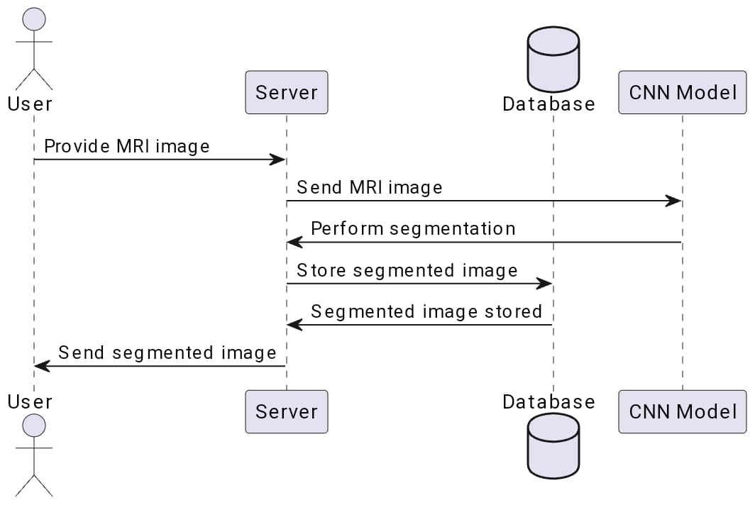
.Figure 2.10.1 Flowchart of brain tumour MRI classification.
Class Diagram
The class diagram can be used to show the classes, relationships, interface, association, and collaboration. UML is standardized in class diagrams. As the class diagram has an appropriate structure to represent the classes, inheritance, relationships, and everything that OOPs have in their context.
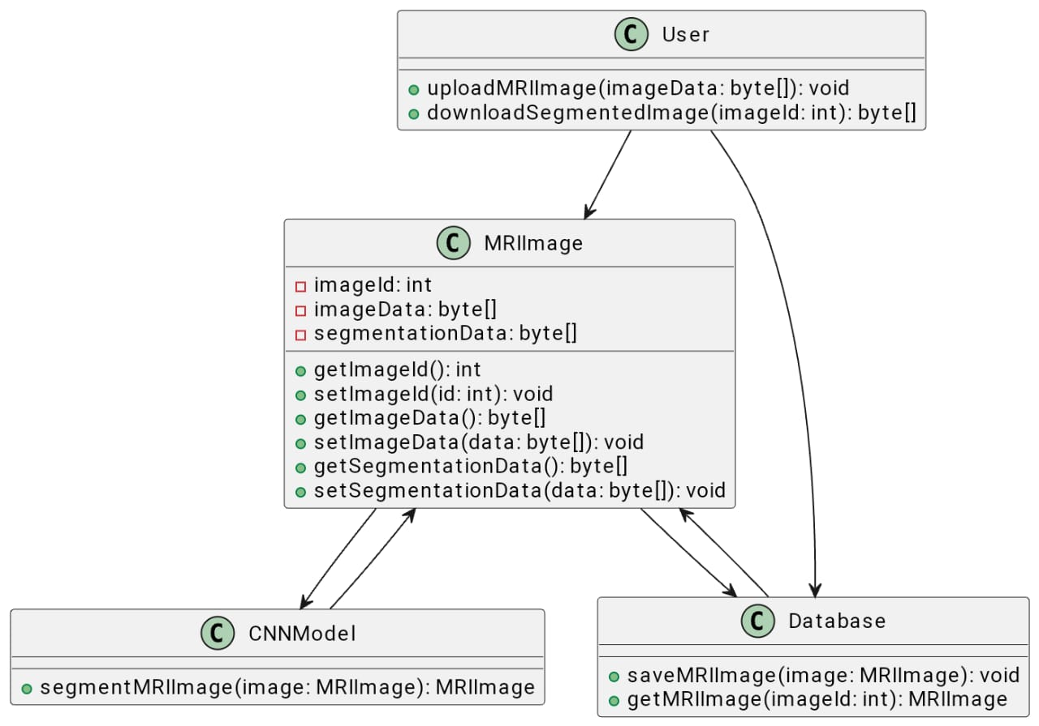
Figure 2.10.2 Class Diagram of brain tumour MRI classification.
Sequence Diagram
A sequence diagram in Unified Modeling Language (UML) is a kind of interaction diagram that shows how processes operate with one another and in 25 what order. It is a construct of a Message Sequence Chart. Sequence diagrams are sometimes called event diagrams, event scenarios, and timing diagrams.
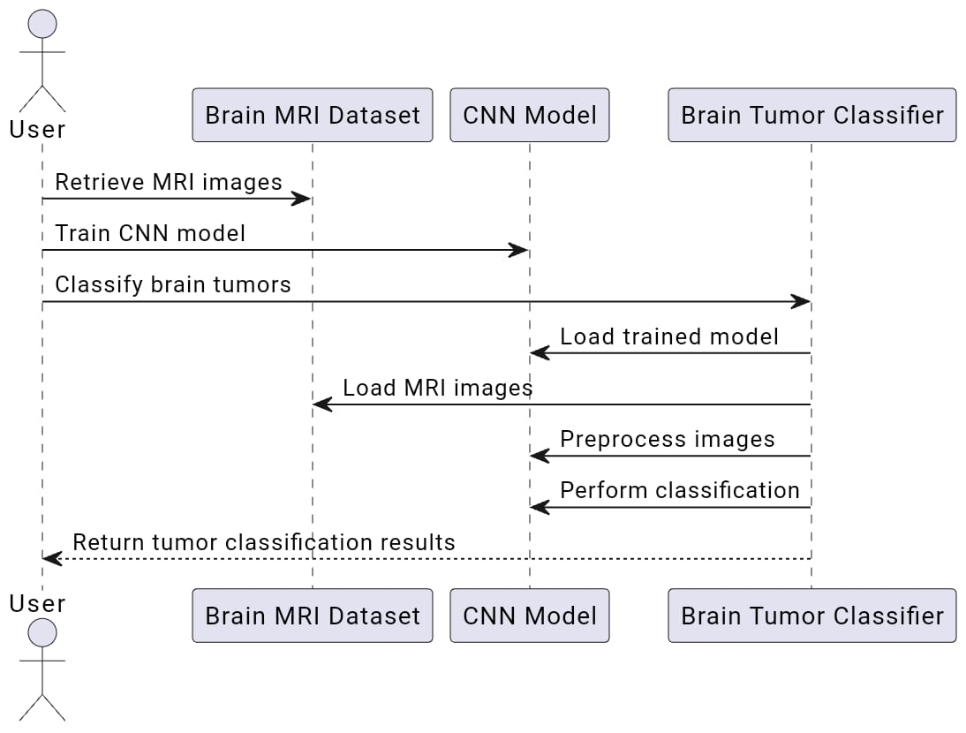
Figure 2.10.3 sequence diagram of brain tumour MRI classification.

CHAPTER 3
Existing Methodology
3.1 Existing Methodology
The methodology in your study appears to be retrospective, involving a cohort of 1028 patients diagnosed with brain tumors between April 2012 and April 2020. You've employed five classification models (Bayesian Rule Lists, Explainable Boosting Machine, Logistic Regression, Random Forest, and Support Vector Machine) to predict one-year survival following diagnosis. Evaluation metrics such as balanced accuracy, F1-score, sensitivity, specificity, and receiver operating characteristics were used to assess model performance.The models were trained on electronic patient records, focusing on features like age, tumor diagnosis, functional attributes, and initial treatment. Intrinsically interpretable models (BRL, EBM, LR) and "black box" models (RF, SVM) were compared for their predictive performance and interpretability. Interpretability was assessed using SHapley Additive exPlanations (SHAP) values to understand feature importance and model decisions.The study delved into explaining misclassifications using EBM and SHAP and investigated the role of feature interactions in prognosis. The conclusion highlights the advantage of interpretable models like EBMs in offering insights into unknown risk factors, potentially enhancing the assessment of brain tumor prognosis beyond traditional clinical evaluation.Overall, the methodology involved a thorough comparison of models, leveraging both interpretable and complex models while focusing on feature importance and interpretability to enhance the understanding and trustworthiness of the predictive models in a clinical context.
PROPOSED METHODOLOGY:
In the study,using a Convolutional Neural Network (CNN), the functional requirements for tumour segmentation might be as follows: Processing of Input Data permitting the insertion of medical photos in a certain format.Through the use of preparing the data for the CNN by applying image preprocessing techniques such as augmentation, normalisation, and scaling.Sample Architecture Convolutional, pooling, and perhaps upsampled or deconvolutional layers for segmentation are all defined in the CNN architecture.Method of Training providing a dataset with labelled tumour locations to aid in the CNN's training.Segmentation training with a way to modify hyperparameters (learning rate, batch size, epochs, etc.) Developing a method to segment and identify tumour locations in new photos by using the trained model.Results Displayed Segmentation photos or masks that show the locations of the tumours that have been discovered and displaying or saving them.To Calculate Performance Metrics. The system must enable the building of a CNN model architecture, which includes importing pretrained models such as VGG-16 and modifying them with layers (Flatten, Dense, Dropout) that are specifically designed for classification.It is required to provide features for model compilation with appropriate optimizers, metrics, and loss functions. This includes the ability to use pre-prepared datasets for model training, as well as control over epochs, batch sizes, validation procedures, early termination mechanisms, and model checkpoints.The ability to calculate and present metrics like accuracy, loss, and other pertinent evaluation parameters is essential for evaluating how well the trained model performs on the test dataset.These functional requirements encapsulate the necessary steps in building a robust CNN-based brain tumor detection system, covering diverse aspects from data handling, model development, training, evaluation, to comprehensive reporting functionalities.

Advantages:
- Accuracy: CNNs are adept at learning intricate patterns in images, allowing for more accurate tumor segmentation compared to traditional methods.
- Automated Processing: Once trained, the CNN can efficiently segment tumors in new images without the need for manual intervention, saving time and effort.
- Generalization:The trained model can generalize patterns learned from the training data to accurately segment tumors in unseen images, increasing its applicability.
- Customizability:The methodology allows for the customization of CNN architectures and hyperparameters, enabling optimization for specific types of tumors or imaging modalities.
- Quantitative Evaluation: The methodology incorporates quantitative metrics (Dice similarity coefficient, IoU, precision, recall, F1-score) for objective evaluation of segmentation accuracy.

Disadvantages:
- Data Quality Dependency: The effectiveness of the CNN heavily relies on the quality and diversity of the dataset. Limited or biased data may lead to inaccurate segmentation.
- Computational Resources: Training CNNs requires significant computational resources (GPU, memory, processing power), making it resource-intensive and time-consuming.
- Hyperparameter Tuning Complexity: Optimizing the CNN's hyperparameters and architecture can be complex, requiring expertise and extensive experimentation.
- Overfitting:* There's a risk of the model overfitting to the training data, resulting in poor generalization to new images and reducing its reliability.
- Post-processing Challenges: Post-processing steps, while refining the segmentation, may introduce subjective biases or errors, affecting the final segmentation quality.
- Interpretability: CNNs often lack interpretability, making it challenging to understand the model's decision-making process, crucial in medical applications where transparency is essential.
- Annotation Requirements:Ground truth annotations for training data are time-consuming and expensive to obtain, especially for medical images requiring expert annotations.
- Balancing these advantages and disadvantages is essential in employing this methodology effectively for tumor segmentation in medical images.
3.1 ADDRESSING ISSUES
Addressing issues in the functional requirements for a Convolutional Neural Network (CNN) used in brain tumor segmentation:
Input Data Processing :
- Insertion of medical photos in a specific format needs clarification. What format is required?
- Clarity on the preprocessing techniques, such as augmentation, normalization, and scaling, and their implementation.
CNN Architecture :
- Detailed clarification on the architecture, specifically regarding upsampling, deconvolutional layers, and their functions in segmentation.
Training Method:
- Specification of how the dataset with labeled tumor locations will be provided for training.
- Clear guidelines on modifying hyperparameters (learning rate, batch size, epochs).
Segmentation in New Photos :
- Development of a clear methodology for segmenting and identifying tumor locations using the trained model in new images.
Display of Results :
- Detailed guidelines on displaying or saving segmented photos or masks effectively.
- Specification of the performance metrics to be calculated and presented.
Model Development and Compilation:
- Specifics on importing and modifying pretrained models like VGG-16 with layers for classification.
- Detailed features for model compilation: optimizers, metrics, loss functions, and their implementation.
Model Training:
- Clear instructions on dataset preparation for model training, including control over epochs, batch sizes, validation procedures, early termination mechanisms, and checkpoints.
Evaluation Metrics :
- Specifics on the calculation and presentation of evaluation metrics like accuracy, loss, and other relevant parameters for assessing model performance on the test dataset.

3.2. Block Diagram of Proposed methodology
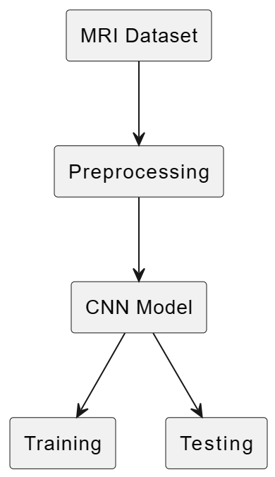

3.3. PROPOSED METHODOLOGY
In the study,using a Convolutional Neural Network (CNN), the functional requirements for tumour segmentation might be as follows: Processing of Input Data permitting the insertion of medical photos in a certain format.Through the use of preparing the data for the CNN by applying image preprocessing techniques such as augmentation, normalisation, and scaling.Sample Architecture Convolutional, pooling, and perhaps upsampled or deconvolutional layers for segmentation are all defined in the CNN architecture.
Method of Training providing a dataset with labelled tumour locations to aid in the CNN's training.Segmentation training with a way to modify hyperparameters (learning rate, batch size, epochs, etc.)
Developing a method to segment and identify tumour locations in new photos by using the trained model.Results Displayed Segmentation photos or masks that show the locations of the tumours that have been discovered and displaying or saving them.
To Calculate Performance Metrics.The system must enable the building of a CNN model architecture, which includes importing pretrained models such as VGG-16 and modifying them with layers (Flatten, Dense, Dropout) that are specifically designed for classification.
It is required to provide features for model compilation with appropriate optimizers, metrics, and loss functions. This includes the ability to use pre-prepared datasets for model training, as well as control over epochs, batch sizes, validation procedures, early termination mechanisms, and model checkpoints.The ability to calculate and present metrics like accuracy, loss, and other pertinent evaluation parameters is essential for evaluating how well the trained model performs on the test dataset.
These functional requirements encapsulate the necessary steps in building a robust CNN-based brain tumor detection system, covering diverse aspects from data handling, model development, training, evaluation, to comprehensive reporting functionalities.
Functionalities for model compilation with suitable loss functions, optimizers, and metrics are necessary. This includes capabilities for training the model using prepared datasets, managing epochs, batch sizes, validation steps, early stopping mechanisms, and model checkpoints.
Evaluation capabilities are crucial to assess the trained model's performance on the test dataset, calculating and displaying metrics such as accuracy, loss, and other relevant evaluation parameters.

CHAPTER 4
RESULTS & DISCUSSIONS
4.1. Data Sets and their description
4.1.1. Review Dataset
Here, We consider " Brain MRI segmentation " Dataset. The data used comes from 110 patients who had a lower-grade glioma brain tumor from The Cancer Genome Atlas (TCGA), and consists of images obtained from The Cancer Imaging Archive (TCIA) as well as manually created fluid-attenuated inversion recovery (FLAIR) masks. The FLAIR technique for MRI’s is meant to suppress darkening cerebrospinal fluid effects on the images, which brings out the contrast between the pixels. In total, there are 3929 images in the data set (Buda, Saha & Mazurowski, 2019).
4.2. Tools and Languages
Language:
Python - Python is a high-level programming language designed to be easy to read and simple to implement. It is open-source, which means it is free to use, even for commercial applications. Python can run on Mac, Windows, and Unix systems and has also been ported to Java and .NET virtual machines.
Python is dynamically typed and garbage-collected. It supports multiple programming paradigms, including procedural, object-oriented, and functional programming. Python is often described as a "batteries included" language due to its comprehensive standard library.
Tools:
Google Colaboratory
Colaboratory, or "Colab" for short, is a product from Google Research. Colab allows anybody to write and execute arbitrary python code through the browser and is especially well suited to machine learning, data analysis, and education. More technically, Colab is a hosted Jupyter notebook service that requires no setup to use, while providing free access to computing resources including GPUs

- NumPy: The abbreviation of NumPy is Numerical Python. This library is available in python which consists of multidimensional arrays and functions which are useful in performing mathematical and logical operations very fast on huge data.
- Pandas: Pandas is a powerful data manipulation and analysis library for Python. It provides data structures and functions to work with structured data, such as data frames and series. It has functions for analyzing, cleaning, exploring, and manipulating data.
- Matplotlib. pyplot: Matplotlib .pyplot is a module in the Matplotlib library, which is a popular Python plotting library for creating static, animated, and interactive visualizations in Python. Matplotlib provides a wide variety of plots and charts, making it a versatile tool for data visualization.
4.3. Performance Metrics
To check the performance of the classifiers, various performance evaluation metrics were used in this project. We evaluated training, validation loss, and training, validation accuracy.
In Deep learning, we have various metrics to evaluate the performance of a model, for example, accuracy, scatter matrix, confusion matrix, Precision, Recall, F1-Score. Some of them are for classification and some for regression tasks. Let us stick to classification metrics in this part. It's very important to select the right performance metric, selecting a performance metric mainly depends upon how data points are distributed in the dataset and related industry experience which plays a vital role.

Accuracy:
Accuracy is the most intuitive performance measure. Accuracy is the number of correct predictions made by the total number of predictions made.
Accuracy = 𝑇𝑃+𝑇𝑁/ 𝑇𝑃+𝐹𝑃+𝑇𝑁+𝐹𝑁
Precision:
- Precision is defined as the number of true positives divided by the number of true positives plus the number of false positives.
Precision = 𝑇𝑃 /𝑇𝑃+𝐹𝑃
Recall:
- A recall is also known as sensitivity. It is the fraction of the total amount of relative relevant instances that were retrieved.
Recall = 𝑇𝑃/𝑇𝑃+𝐹𝑁
F1-Score:
- F 1 Score is the weighted average or the harmonic mean of Precision and Recall taking both metrics into account in the following equation:
F1 Score = 2 x precision * recall/ precision +recall
Scatter matrix:
A scatter plot matrix is a grid (or matrix) of scatter plots used to visualize bivariate relationships between combinations of variables. Each scatter plot in the matrix visualizes the relationship between a pair of variables, allowing many relationships to be explored in one chart.
Confusion Matrix:
The confusion matrix is a technique used for summarizing the performance of a classification algorithm i.e. it has binary outputs. A Confusion matrix is an N x N matrix used for evaluating the performance of a classification model, where N is the number of target classes. The matrix compares the actual target values with those predicted by the machine learning model. This gives us a holistic view of how well our classification model is performing and what kinds of errors it is making.
4.4. Results and its Discussions
From this code, we have first taken all the libraries, dataset, and check in details.
the detection of brain tumours through the use of sophisticated machine learning methods, namely the analysis of MRI data using the VGG16 architecture in conjunction with transfer learning. The goal is to create a model that provides a more thorough understanding of MRI images than existing classification techniques by outperforming them in terms of accuracy, speed, and reliability.
This research should lead to a major improvement in the classification of brain tumours, which could result in quick and accurate diagnosis information. The study intends to develop a useful tool for radiologists and oncologists, assisting in more informed treatment decisions, by utilising VGG16 and transfer learning.
The increasing prevalence and death rates of brain tumours are highlighted in the discussion, along with their impact on global health and the urgent need for accurate classification. The reason behind the project is the shortcomings of the available diagnostic.The limited capabilities of the available diagnostic techniques are the driving force behind the project, which emphasises how sophisticated machine learning can help overcome these obstacles in medical imaging.
If this study is successful, it may lead to better patient outcomes by enabling more knowledgeable treatment choices. Furthermore, as this study shows, deep learning can be applied to healthcare to improve patient care and diagnostic processes in neurology. It may also pave the way for future developments in cancer and medical imaging.
Result:
Test accuracy : 77.09923386573792

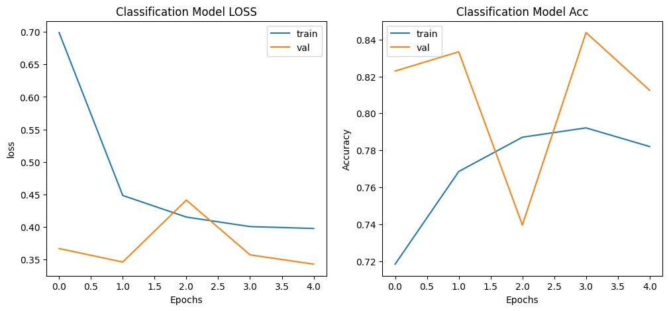

Classification model loss Classification model accuracy

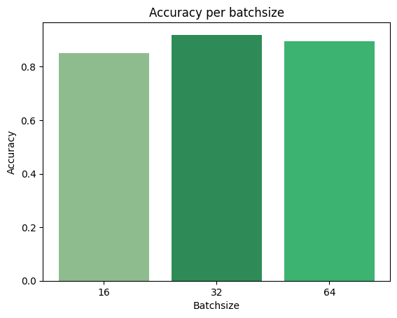
Accuracy per batchsize

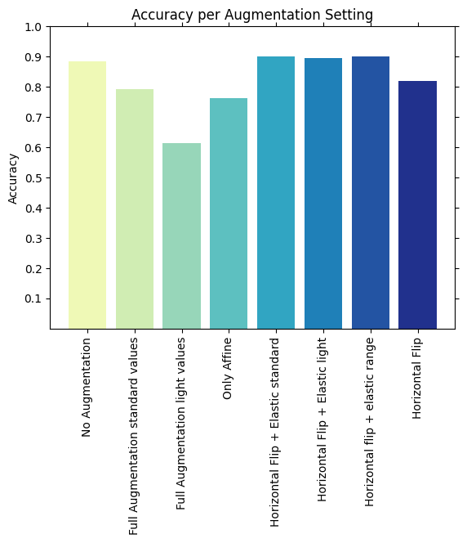
Accuracy per Augmentation Setting

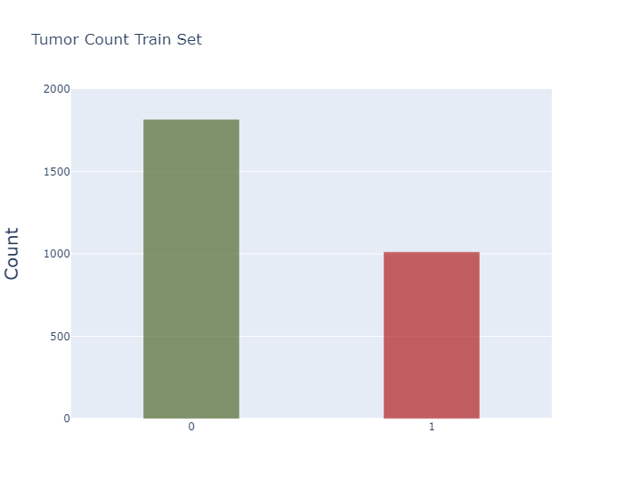
:Tumor Count Train Set

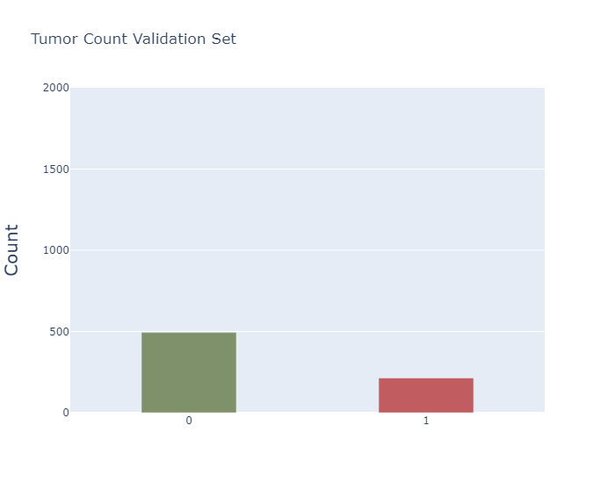
Tumor Count Validation Set
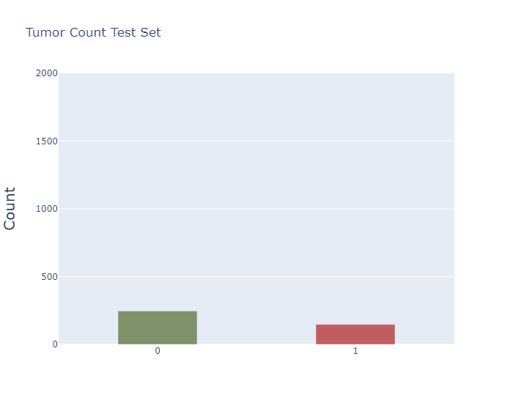
Tumor Count Test Set

CHAPTER 5

CONCLUSIONS AND FUTURE SCOPE
After five epochs of training, the model achieved a validation accuracy of 81.25% and a test accuracy of 77.09%. These results demonstrate the potential of using the VGG16 architecture combined with transfer learning to classify brain tumors in MRI images. The relatively high validation accuracy indicates that the model effectively learns and generalizes from the training data. However, the slight discrepancy between validation and test accuracies suggests there might be room for further optimization to enhance the model's performance and generalizability.
The study opens up multiple avenues for future research and application. One immediate area for development is the model's training process. Increasing the number of epochs, fine-tuning the hyperparameters, or augmenting the dataset could improve accuracy and reduce the gap between validation and test performance. Additionally, experimenting with other pre-trained models or advanced neural network architectures might yield better or more efficient results.
In terms of application, integrating this model into clinical settings could provide radiologists with a powerful tool for preliminary tumor classification, potentially speeding up the diagnostic process and aiding in early treatment planning. Future research could also explore the model's effectiveness in classifying different types of brain tumors or in multi-class settings beyond binary classification.
Another promising direction is incorporating this technology into telemedicine platforms, especially in regions with limited access to expert radiological analysis. This could democratize high-quality medical diagnostics and contribute to more equitable healthcare access.

REFERENCES
[1] M.T.C. Poon, C.L.M. Sudlow, J.D. Figueroa, P.M. Brennan, Longer-term (≤ 2
years) survival in patients with glioblastoma in population-based studies
pre-and post-2005: a systematic review and meta-analysis, Sci. Rep. 10 (2020)
1–10.
[2] E.B. Claus, et al., Survival and low-grade glioma: the emergence of genetic in
formation, Neurosurg. Focus 38 (2015) E6.
[3] R. Jain, et al., Outcome prediction in patients with glioblastoma by using imag
ing, clinical, and genomic biomarkers: focus on the nonenhancing component
of the tumor, Radiology 272 (2014) 484–493.
[4] K. Kourou, T.P. Exarchos, K.P. Exarchos, M.V. Karamouzis, D.I Fotiadis, Ma
chine learning applications in cancer prognosis and prediction, Comput. Struct.
Biotechnol. J. 13 (2015) 8–17.
[5] P. Fulop, A. Manataki, A. Agachi, P. Pop, Predicting survival after surgery for
brain tumour patients: A machine learning study on clinical data and molec
ular data, in: Proceedings of the AI for Social Good workshop, 7th International
Conference on Learning Representations, 2019.
[6] M.T. Ribeiro, S. Singh, C. Guestrin, "Why should I trust you?” Explaining the
predictions of any classifier, in: Proceedings of the ACM SIGKDD International
Conference on Knowledge Discovery and Data Mining, 2016, pp. 1135–1144.
[7] J.T. Senders, et al., An online calculator for the prediction of survival in
glioblastoma patients using classical statistics and machine learning, Neuro
surgery 86 (2020) E184–E192.
[8] L.J. Wei, The accelerated failure time model: a useful alternative to the cox
regression model in survival analysis, Stat. Med. 11 (1992) 1871–1879.
[9] P.I. D’Urso, Letter: an online calculator for the prediction of survival in glioblas
toma patients using classical statistics and machine learning, Neurosurg 87
(2020) E273–E274.
[10] M.A. Ahmad, C. Eckert, A. Teredesai, G. McKelvey, Interpretable machine learn
ing in healthcare, IEEE Intell. Info. Bull. 19 (2018) 1–7.
[11] C. Rudin, Stop explaining black box machine learning models for high stakes
decisions and use interpretable models instead, Nat. Mach. Intell. 1 (2019)
206–221.
[12] T. Miller, Explanation in artificial intelligence: insights from the social sciences,
Artif. Intell. 267 (2019) 1–38.
[13] D.V. Carvalho, E.M. Pereira, J.S. Cardoso, Machine learning interpretability: a
survey on methods and metrics, Electronics 8 (2019) 832.
[14] Molnar, C. Interpretable Machine Learning. (2019). Available online: https://
christophm.github.io/interpretable-ml-book/(accessed on 10 August 2021).
[15] B. Letham, C. Rudin, T.H. McCormick, D. Madigan, Interpretable classifiers using
rules and Bayesian analysis: Building a better stroke prediction model, Ann.
Appl. Stat. 9 (2015) 1350–1371.
[16] Nori, H., Jenkins, S., Koch,P. & Caruana, R. InterpretML: A unified framework for
machine learning interpretability. Preprint at https://arxiv.org/abs/1909.09223
(2019).
[17] S. Menard, Applied logistic regression analysis No. 106, Sage, 2002.
[18] L. Breiman, Random forests, Mach. Learn. 45 (2001) 5–32.
[19] J.A.K. Suykens, J. Vandewalle, Least squares support vector machine classifiers,
Neural Process. Lett. 9 (1999) 293–300.
[20] S.M. Lundberg, S. Lee, A unified approach to interpreting model predictions,
Adv. Neural Inf, Process Syst. 30 (2017).
[21] G.S. Collins, J.B. Reitsma, D.G. Altman, K.G. Moons, Transparent reporting of a
multivariable prediction model for individual prognosis or diagnosis (TRIPOD):
the TRIPOD statement, BR. J. Surg. 102 (2015) 148–158.
[22] Rossum, G. V. & Drake, L. F. Python language reference manual. (2003).
[23] W. McKinney, et al., Data structures for statistical computing in python, in:
Proceedings of the 9th Python in Science Conference, 445, 2010, pp. 51–56.
[24] T.E. Oliphant, A guide to NumPy, Trelgol Publishing, 2006.
[25] J.D. Hunter, Matplotlib: A 2d graphics environment, Comput. Sci. Eng. 9 (2007)
90–95.
[26] F. Pedregosa, et al., Scikit-learn: machine learning in Python, JMLR 12 (2011)
2825–2830.
[27] Alvarez-Melis, D. & Jaakkola, T. S. On the robustness of interpretability meth
ods. Preprint at https://arxiv.org/abs/1806.08049 (2018).
[28] L. Antwarg, R.M. Miller, B. Shapira, L. Rokach, Explaining anomalies detected
by autoencoders using Shapley additive explanations, Expert Syst. Appl. 186
(2021) 115736.
[29] M.E. Tipping, Sparse Bayesian learning and the relevance vector machine, JMLR
1 (2001) 211–244.
[30] S.V. Buuren, K. Groothuis-Oudshoorn, MICE: Multivariate imputation by
chained equations in R, J. Stat. Softw. 45 (2011) 1–67.
[31] J.W. Grzymala-Busse, J Stefanowski, Three discretization methods for rule in
duction, Int. J. Intell. Syst. 16 (2001) 29–38.
[32] D.A. Karnofsky, W.H. Abelmann, L.F. Craver, J.H. Burchenal, The use of the ni
trogen mustards in the palliative treatment of carcinoma. with particular ref
erence to bronchogenic carcinoma, Cancer 1 (1948) 634–656.
[33] S. Varma, R Simon, Bias in error estimation when using cross-validation for
model selection, BMC Bioinform 7 (2006) 91.
[34] M. Hossin, M.N. Sulaiman, A review on evaluation metrics for data classifica
tion evaluations, IJDKP 5 (2015) 1.
[35] A.P. Bradley, The use of the area under the ROC curve in the evaluation of
machine learning algorithms, Pattern Recognit. 30 (1997) 1145–1159.
[36] C. Borgelt, An implementation of the FP-growth algorithm, in: Proceedings of
the 1stinternational workshop on open source data mining: frequent pattern
mining implementations, 2005, pp. 1–5.
[37] K.W. Hastings, Monte Carlo sampling methods using Markov chains and their
applications, Biometrika 57 (1970) 97–109.
[38] L.E. Eberly, G. Casella, Estimating Bayesian credible intervals, J. Stat. Plan. In
ference 112 (2003) 115–132.
[39] S.N. Wood, Generalized additive models: an introduction with R, CRC press,
2017.
[40] J. Park, I.W. Sandberg, Universal approximation using radial-basis-function net
works, Neural Comput. 3 (1991) 246–257.
[41] A.E. Roth, The Shapley value: essays in honor of Lloyd S. Shapley, Cambridge
University Press, 1988.
[42] M. Szumilas, Explaining odds ratios, J. Can. Acad. Child Adolesc. 19 (2010) 227.
[43] S.R. Dehcordi, Survival prognostic factors in patients with glioblastoma: our
experience, J. Neurosurg. Sci. 56 (2012) 239–245.
[44] H. Gittleman, Survivorship in adults with malignant brain and other central
nervous system tumor from 2000–2014, Neuro-Oncol 20 (2018) vii6–vii16.
[45] S. Lapointe, A. Perry, N.A. Butowski, Primary brain tumours in adults, The
Lancet 392 (2018) 432–446.
[46] S. Podnar, et al., Diagnosing brain tumours by routine blood tests using ma
chine learning, Sci. Rep. 9 (2019) 1–7.
[47] P.A. Glare, C.T. Sinclair, Palliative medicine review: prognostication, J. Palliat.
Med. 11 (2008) 84–103.
[48] S. Cheon, et al., The accuracy of clinicians’ predictions of survival in advanced
cancer: a review, Ann. Palliat. Med. 5 (2016) 22–29.
[49] R. Caruana, et al., Intelligible models for healthcare: Predicting pneumo
nia risk and hospital 30-day readmission, in: Proceedings of the 21th ACM
SIGKDD international conference on knowledge discovery and data mining,
2015, pp. 1721–1730.
[50] M.S. Pepe, H. Janes, G. Longton, W. Leisenring, P. Newcomb, Limitations of the
odds ratio in gauging the performance of a diagnostic, prognostic, or screening
marker, Am. J. Epidemiol. 159 (2004) 882–890.
[51] I.A. Tewarie, Survival prediction of glioblastoma patients—Are we there yet?
A systematic review of prognostic modeling for glioblastoma and its clinical
potential, Neurosurg. Rev. 44 (2021) 2047–2057.
[52] D. Slack, S. Hilgard, E. Jia, S. Singh, H. Lakkaraju, Fooling LIME and SHAP:
Adversarial attacks on post hoc explanation methods, in: Proceedings of the
AAAI/ACM Conference on AI, Ethics, and Society, 2020, pp. 180–186.
[53] T. Laugel, M. Lesot, C. Marsala, X. Renard, M. Detyniecki, The dangers of
post-hoc interpretability: Unjustified counterfactual explanations, in: Proceed
ings of the 28th International Joint Conference on Artificial Intelligence, AAAI,
2019, pp. 2801–2807.
[54] B. Dimanov, U. Bhatt, M. Jamnik, A. Weller, You shouldn’t trust me: Learning
models which conceal unfairness from multiple explanation methods, SafeAI@
AAAI (2020) 63–73.
[55] L. Breiman, J.H. Friedman, R.A. Olshen, C.J. Stone, Classification and regression
trees, Routledge, 2017.
[56] J. Salo, A. Niemelä, M. Joukamaa, J. Koivukangas, Effect of brain tumour later
ality on patients’ perceived quality of life, JNNP 72 (2002) 373–377.
[57] E. Gray, et al., Health economic evaluation of a serum-based blood test for
brain tumour diagnosis: exploration of two clinical scenarios, BMJ Open 8
(2018) e017593.
[58] G. Ambler, R.Z. Omar, P Royston, A comparison of imputation techniques for
handling missing predictor values in a risk model with a binary outcome, Stat.
Methods Med. Res. 16 (2007) 277–298.
[59] C.T. Tran, M. Zhang, P. Andreae, B. Xue, L.T Bui, An effective and efficient ap
proach to classification with incomplete data, Knowl. Based Syst. 154 (2018)
1–16.
[60] H.M. Proenca, M. van Leeuwen, Interpretable multiclass classification by MDL
based rule lists, Inf. Sci. 512 (2020) 1372–1393.
[61] D. Frappaz, et al., Assessment of Karnofsky (KPS) and WHO (WHO-PS) perfor
mance scores in brain tumour patients: The role of clinician bias, Support. Care
Cancer 29 (2020) 1–9.
[62] J.B. Sørensen, M. Klee, T. Palshof, H.H. Hansen, Performance status assessment
in cancer patients. an inter-observer variability study, Br. J. Cancer 67 (1993)
773–775.
[63] K. Chaichana, S. Parker, A. Olivi, A. Qui˜nones-Hinojosa, A proposed classifica
tion system that projects outcomes based on preoperative variables for adult
patients with glioblastoma multiforme, J. Neurosurg. 112 (2010) 997–1004.
[64] M. Ozawa, The usefulness of symptoms alone or combined for general prac
titioners in considering the diagnosis of a brain tumour: a case-control study
using the clinical practice research database (CPRD) (2000-2014), BMJ Open 9
(2019) e029686.
[65] The Brain Tumour Charity. Adult brain tumour types. 2020. Available online:
https://www.thebraintumourcharity.org/brain-tumour-diagnosis-treatment/
types-of-braintumour-adult (accessed on 1 August 2021).
[66] M.M. Oken, et al., Toxicity and response criteria of the eastern cooperative on
cology group, Am. J. Clin. Oncol. 5 (1982) 649–656.

